How to use the ClubSpark Booker App
If you haven't already, you should download the ClubSpark booker app on IOS or Android by searching for ‘ClubSpark’ on your app store.
Sign into the app, using the same account as you use to sign into ClubSpark and then select 'Make a Booking'.
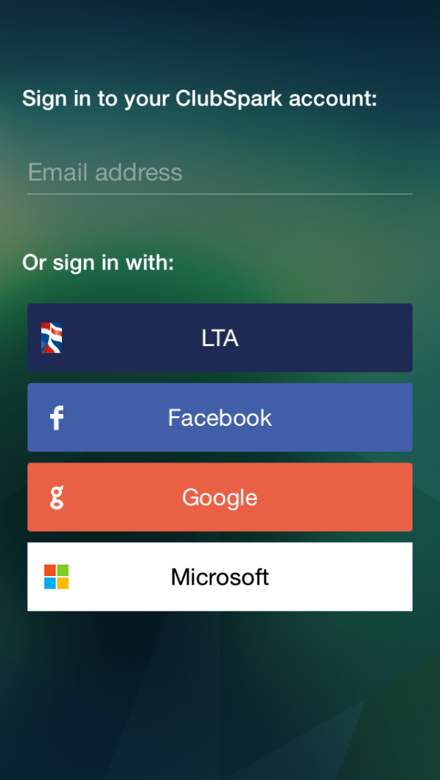

The app will automatically recognize which venues you’re registered with. Click on the venue name to select which venue you would like to book a court at.
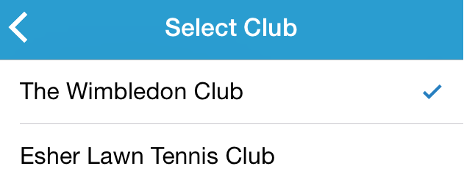

Select your court type, followed by the day which you would like to play.
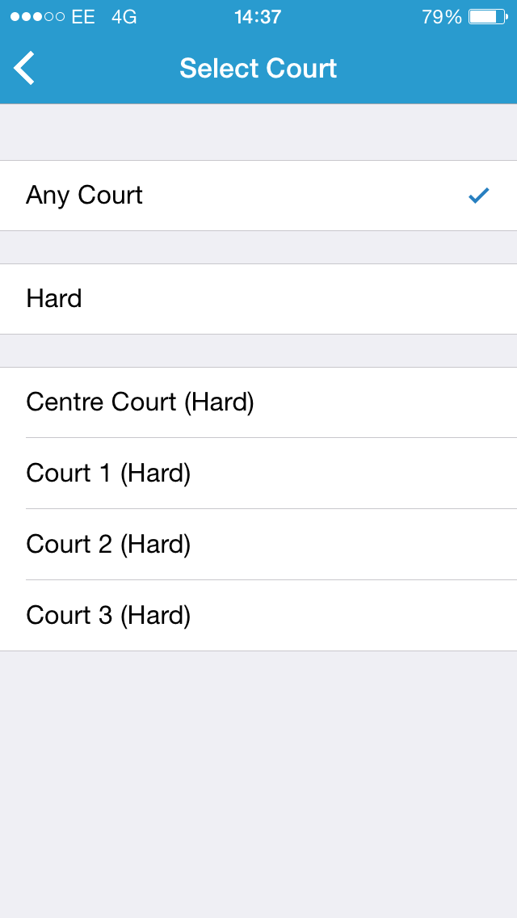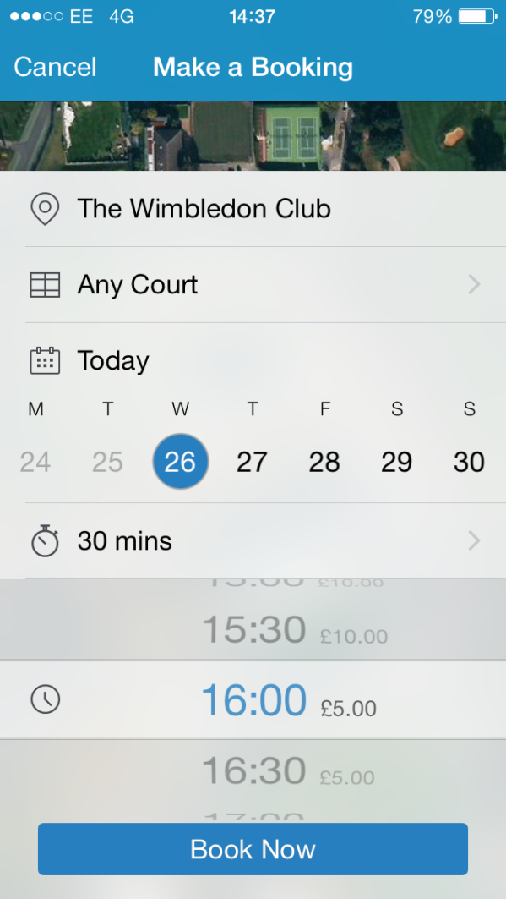
Now select your duration and the time which you would like to play. Please note, only available times will be displayed.
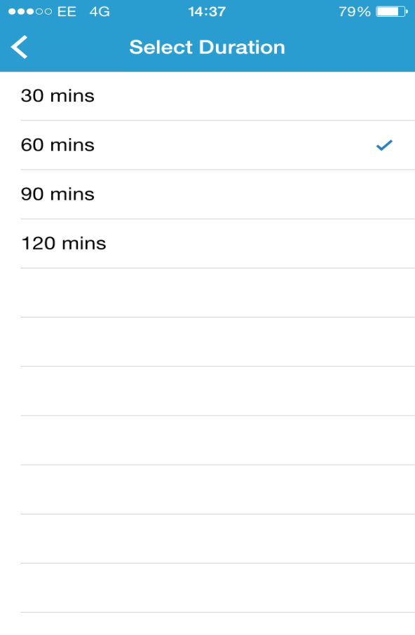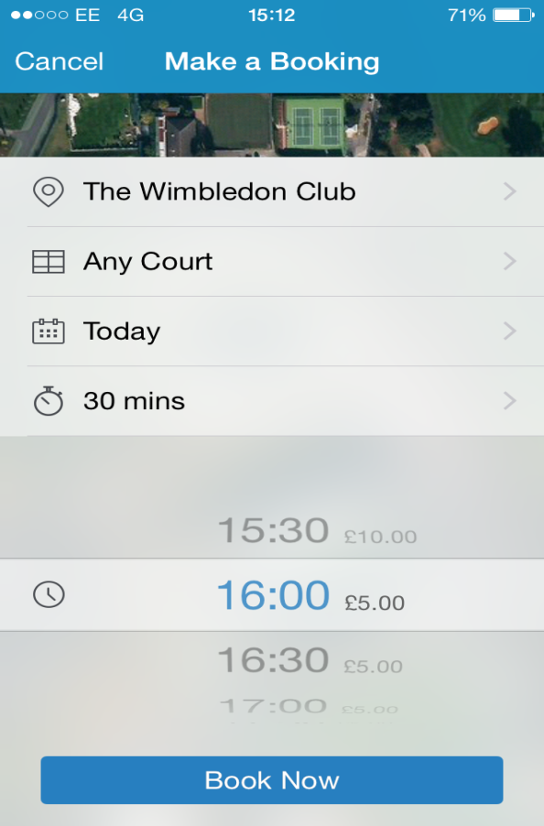
Selecting 'Book Now' will bring up the confirmation overlay. If there is a payment associated with the booking you will need to enter your card details, if not you will be able to just confirm the booking.
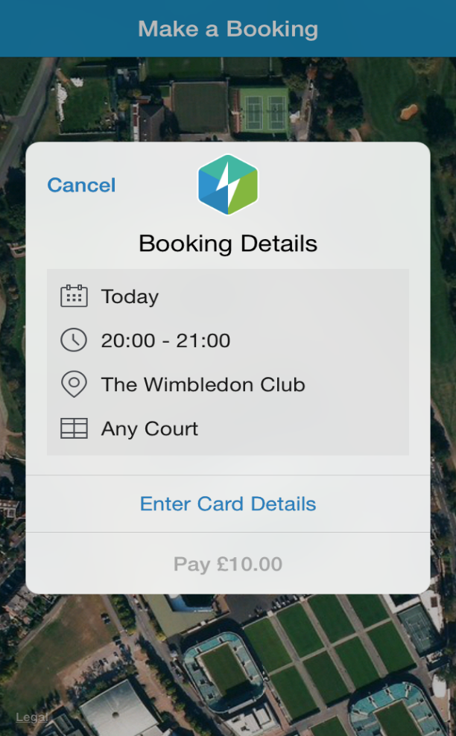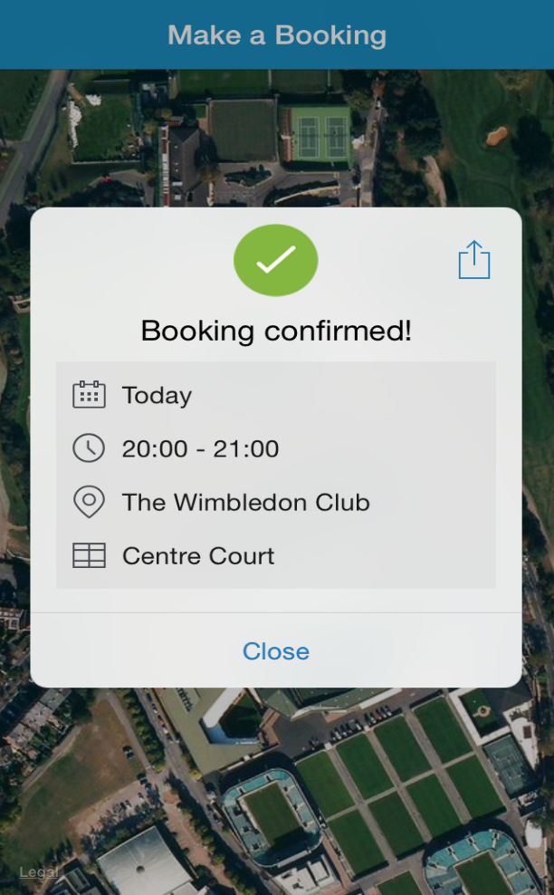
Your booking will then appear in your 'Coming Up' tab.
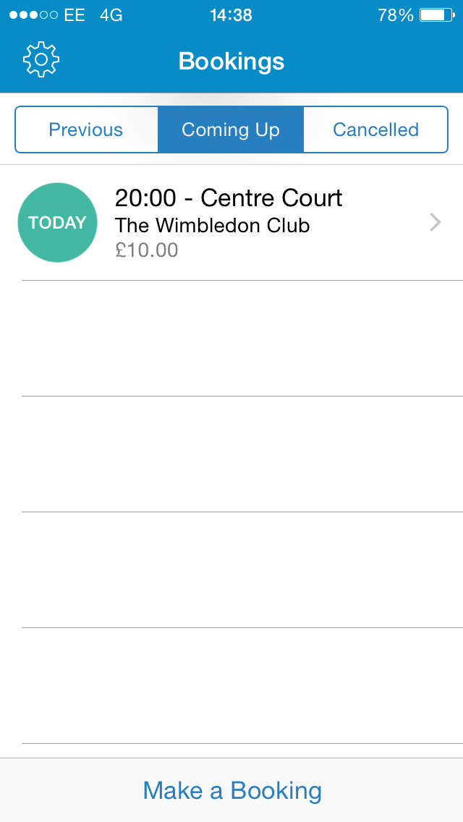
The app is synced to your venues booking sheet, so any bookings made on the app, will also be added to your venues booking sheet.

